|  |  |
| --- | --- |
| Student number | 19000915 |
| Main text body word count | 900 (Part I) + 395 (Part II) = 1295 (Overall) |
|  |  |
|  |  |
| **Reflective abstract (up to 150 words)**  Please help the marker give you useful, personally-tailored, feedback by completing the sections below. Nothing you write here will adversely affect your mark. | |
| What mark do you anticipate your essay will achieve? | Over 70% hopefully |
| What do you think you did well in the writing of this essay? | Evidence and Analysis |
| What aspects of your essay do you think may need improvement? | Reflective Report and Reflections chapter |
| What areas of feedback would be most helpful for you? | Everything included in the report. |

# PART I – CRITICAL REVIEW

# 1.1 INTRODUCTION

The main topic of this report is the diagrammatic framework ***Lucidchart***, which will be critically reviewed based on a set of evaluation criteria.

# 1.2 EVALUATION CRITERIA

The cost, capabilities, performance, and usability represent the evaluation criteria for the selected framework. The cost will be determined from the website of the software provider. Its capabilities will be evaluated by the features and services it supports, such as collaboration features. Its performance will be tested easily using a stress test, which will include combining all diagrams used in this critical assessment into a single document and assessing whether this has any effect on performance in terms of lag, stuttering, and delay. Usability will be evaluated based on the features that make producing diagrams easier.

## 1.2.1 Cost

The price of this framework is dependent on the subscription plan you pick. Individual licenses cost roughly 6.50 pounds per month, while a team license cost around 30 pounds per month. The enterprise is the final price plan option provided, and selecting this option requires a quote from Lucidchart itself. This is a fair price for a software framework like Lucidchart because the cost of it is quite modest when compared to Microsoft Visio and Griffey (Faulkner, 2018). As a result, in terms of cost, Lucidchart represents an excellent choice.

# 1.3 EVIDENCE (WITH EXAMPLE ILLUSTRATIONS) AND ANALYSIS

## 1.3.1 Capabilities

Lucidchart offers a variety of basic shapes to help users create diagrams, as shown in ***Figure 1***. The shapes needed to make the component diagram were automatically included in ***Figure 2***. Duffy says that Lucidchart is an excellent tool for creating shapes that are often seen in professional diagrams, which suggests that Lucidchart is versatile and can be used to create a wide variety of diagrams (Duffy, 2020).

Lucidchart also supports the import option for new shapes in the form of SVGs and Visio Stencil files. All of these characteristics enable the creation of any diagram a user may require, giving greater versatility. Due to “the number of templates and shapes may make or break diagramming software”, these capabilities are critical (Duffy, 2020).

Lucidchart, like with templates and shapes, provides a good variety of lines, which is vital for accurate connection representation in diagrams, which is needed in some UML diagrams and other similar diagrams such as business-type models like the one shown in ***Figure 3*** and ***Figure 4*** depicting the transition from requirements expressed as use cases to the more explicit and formal level of refinement.

Another essential advantage included by Lucidchart is the ability to generate sequence diagrams using UML markup, as shown in ***Figure 5***. This technique is far superior to the other depicted in ***Figure 3***, because “textual modelling tools offer a very low barrier to access” (Modelling Languages, 2020). That is, they learn really quickly. It is also significantly faster to build diagrams since all of the heavy work, such as formatting the diagram and dragging and dropping shapes is done automatically. This made creating the diagram incredibly quick and simple.

According to Lucidchart's page “***How to Collaborate in Real-Time***”, it is possible to collaborate with other team members on a document in real-time (Lucidchart). This functionality offers several advantages, including making workflow tracking easier and improving cooperation in teams that work remotely (Nit.AI Blog 2018).

Lucidchart also keeps track of version history (***Figure 6*)**. This functionality, however, is only available to those who have purchased the teams’ version of Lucidchart. Version history is an **important** feature because it saves users from making irrevocable mistakes by allowing them to return to an earlier version of their document; this is especially valuable when numerous users are working on the same page.

## 1.3.2 Performance

To test larger diagrams, all of the diagrams were combined into a single document (***Figure 7***) and tested to assess how well the web application functioned. According to the findings, the more shapes on the document, the greater latency the user perceives. This is a major problem since latency and stuttering might impede productivity because the hold window would freeze, requiring the user to wait to make additional changes. Other users have encountered similar issues. One user, for example, stated that Lucidchart was useless due to latency (Lucid Learning Campus, 2021). Other concerns, such as delayed loading times (Lucid Learning Campus, 2020), have been mentioned.

## 1.3.3 Usability

The overall usability is excellent, with a clear chart that is simple to use. According to one review, Lucidchart is simple to use and has a short learning curve (UX Matters, 2015).

As the Requirements model displayed in ***Figure 8*** shows, it is feasible to execute operations that would ordinarily be done in word processing software such as Microsoft Word in Lucidchart. There are two methods to achieve this: putting all text in objects or double-clicking anywhere on the documents to create a text box. The advantage of Lucidchart is that it offers basic word processing skills, such as a spell checker, which can be easily activated, as seen in ***Figure 9***.

Lucidchart allows users to easily align text and graphics, as seen in ***Figure 10***, within a diagram, which is helpful in keeping diagrams tidy and easy to read (Dabbah, 2013).

# 1.4 CONCLUSIONS

Lucidchart is a powerful diagramming tool that allows users to create diagrams using UML markup and features a variety of other features, like spell-checking and alignment tools. However, it does have some limitations, such as its slow performance. However, its lower cost is a major advantage over other diagramming tools.

# PART II − REFLECTIVE REPORT

# 2.1 INTRODUCTION

After working and experimenting with Lucidchart, I gained the necessary knowledge in creating and customizing the diagrams of an enterprise system, which corresponds to the understanding and transcription of requirements in these diagrams and schemes and further putting these into code.

# 2.2 REFLECTIONS

## 2.2.1 Docker and Django

**Django** accomplished the key goals by addressing the fundamentals and simplifying the development process (Dauzon S., Bendoraitis A. and Ravindran A., 2016), and it allowed me to focus on the more sophisticated and distinctive parts of the project while **Docker** made the development and deployment process less expensive (Fouda, 2022) by allowing me to run several containers on a single server, resulting in more effective resource use.

## 2.2.2 Add Film method

Django applications are more complex to write, but they are easier to maintain because they are standardized. While implementing the method shown in ***Figure 11***,I encountered issues when I wanted to instantiate the form and take the data to store them in the database, especially at line 18. When Django processes a file upload, the file data ends up in the ***request.FILES***, which is a dictionary with a key for each FileField in the form. After reviewing the Django documentation, I managed to retrieve the uploaded image and display it properly, as can be seen in ***Figure 12***.

Another great feature of Django is represented by Models. They serve as the foundation of every Django project (Dauzon S., Bendoraitis A. and Ravindran A., 2016) and are used in web applications to retrieve and manipulate data from databases. The model presented in ***Figure 11*** is based on the **Film** class which contains different fields such as ***title***, age rating, duration, and trailer description which are taken from the form as can be seen in lines 12-16 and are dynamically loaded into the main website. I think a good practice of using models for this software is represented by their **simplicity**, **consistency**,and **version control** − Python is easier, and also less error-prone, and more efficient, while SQL is inconsistent between databases; besides, keeping track of design changes is made easier by storing models in my codebase. **Dockerizing** the code made the deployment very easy, that being another good practice.

# 2.3 CONCLUSIONS

Django is a powerful framework used by businesses to rapidly and easily construct web applications and the models drastically simplified the assignment tasks by organizing the tables into models. Thanks to Django, the inheritance and overloading operations in Python are very easier for me to understand now, and the assignment demonstrates that the knowledge obtained from it has been successfully applied to the project.

# References

[Dabbah](https://about.tiny.cloud/blog/author/daviddabbah/), D.D (2013) Tiny. Available from: <https://about.tiny.cloud/blog/the-importance-of-spell-checking-and-protecting-your-online-brand/> [Accessed 11 December 2022].

Dauzon, S., Bendoraitis, A. and Ravindran, A. (2016) Django: web development with python : from an idea to a prototype--a complete guide for web development with the Django framework Packt Publishing.

<Duffy>, J.D (2020) Lucidchart. Available from: <https://uk.pcmag.com/productivity-2/86093/lucidchart> [Accessed 11 December 2022].

Faulkner, A.F. (2018) Lucidchart for Easy Workflow Mapping, *Serials Review* [online]. Volume 44, page 157-162. [Accessed 14 December 2022].

Fouda, E. (2022) A Complete Guide to Docker for Operations and Development: Test-Prep for the Docker Certified Associate (DCA) Exam Berkeley, CA, Apress L. P.

Lucidchart (No Date) How to Collaborate in Real-Time. Available from: [https://www.lucidchart.com/pages/videos/real-time-collaboration-feature](https://www.lucidchart.com/pages/videos/real-time-collaboration-feature%20) [Accessed 14 December 2022].

Lucid Learning campus (2021) new lucid is lagging severely. Available from: [https://lucidchart.zendesk.com/hc/en-us/community/posts/4410336240660-new-lucid-is-lagging-severely [Accessed 14 December 2022](https://lucidchart.zendesk.com/hc/en-us/community/posts/4410336240660-new-lucid-is-lagging-severely%20%5bAccessed%2014%20December%202022)]

Lucid Learning campus (2020) new lucid is lagging severely. Available from: <https://lucidchart.zendesk.com/hc/en-us/community/posts/360073289191-Lucidchart-is-getting-too-slow-and-today-outage> [Accessed 14 December 2022]

Modelling Languages (2020) Text to UML and other “diagrams as code” tools – Fastest way to create your models. Available from: <https://modeling-languages.com/text-uml-tools-complete-list/> [Accessed 10 December 2022]

Nit. AI Blog (2018) 9+ Benefits of Collaboration For Teams and Businesses!, Available from: <https://blog.bit.ai/benefits-of-collaboration/> [Accessed 14 December 2022].

UX Matters (2015) Product Review: Lucidchart. Available from: [https://www.uxmatters.com/mt/archives/2015/07/product-review-lucidchart.php](https://www.uxmatters.com/mt/archives/2015/07/product-review-lucidchart.php%20) [Accessed 26 December 2022].

# Appendix A

**Github Link:** <https://github.com/andrei2timo/ESD-UWEFlix-Cinema-Component-A.git>

# Appendix B

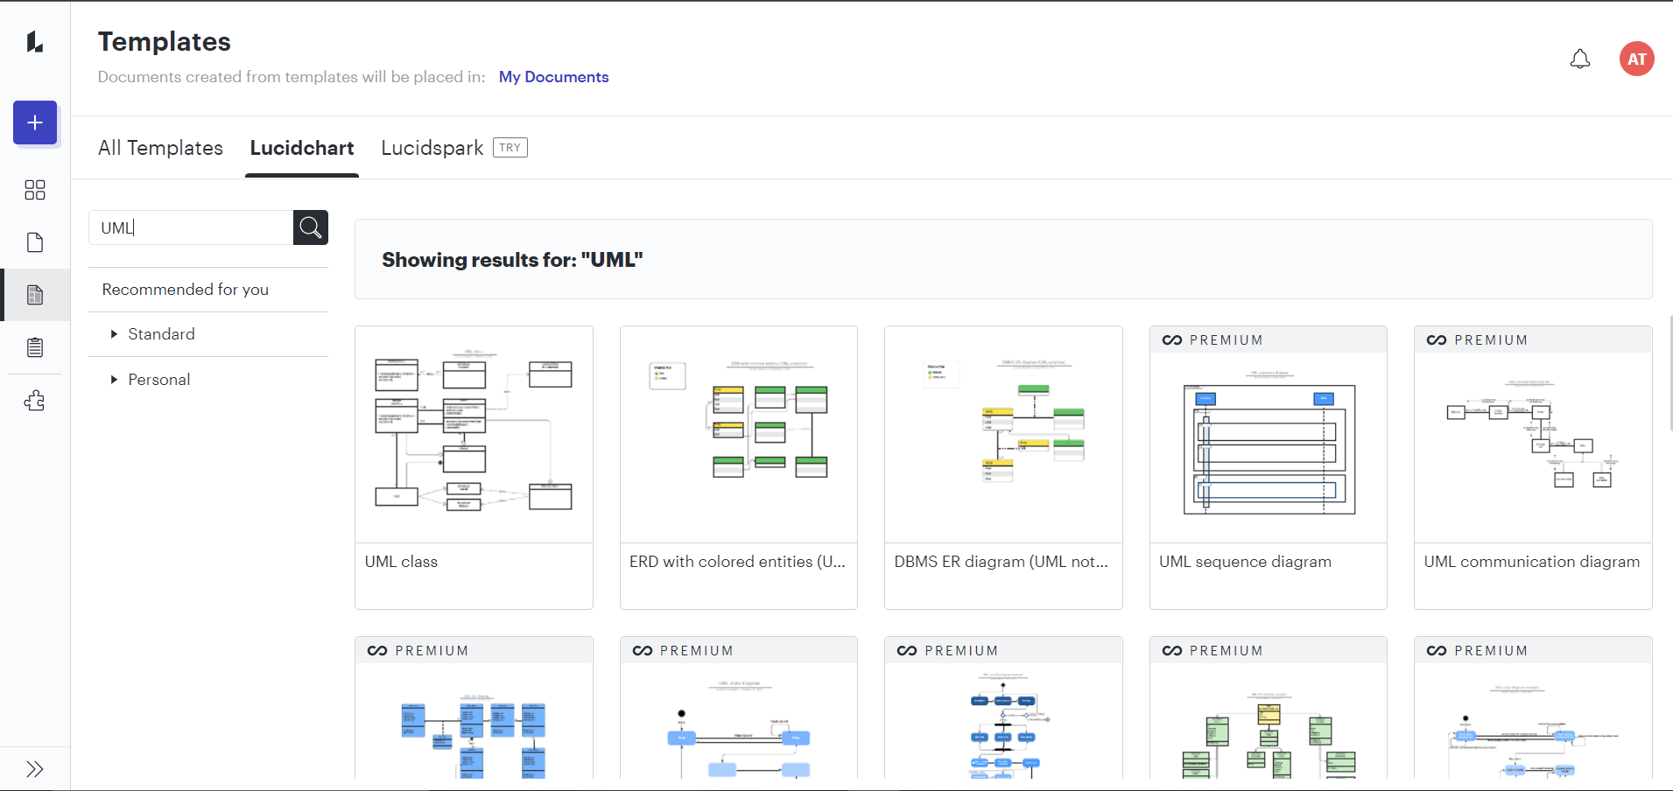**Figure 1: Start-up menu of Lucidchart**

**Figure 2: Component Diagram for UWEFlix Cinema System**

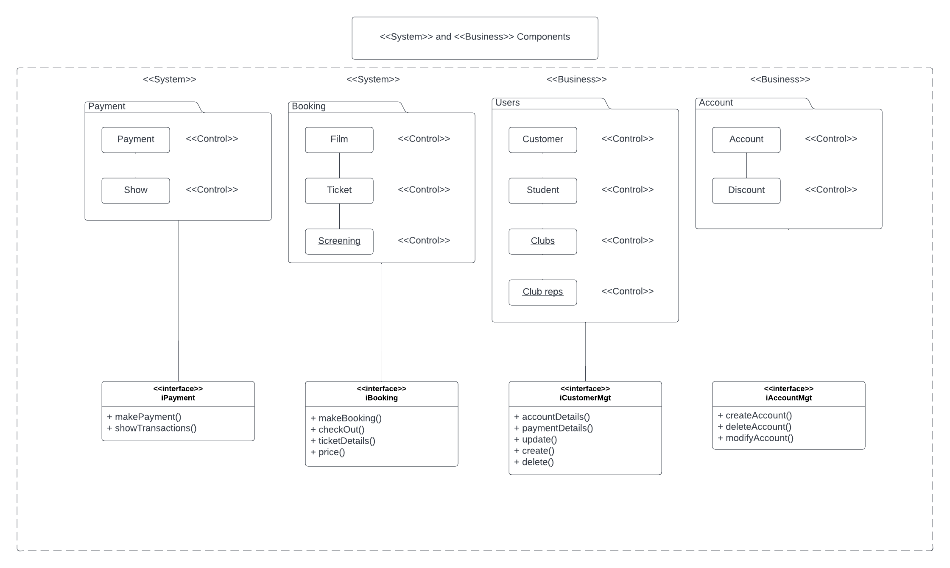

**Figure 3: Sequence Diagram for UWEFlix Cinema System**

**Figure 4: Sequence Diagram for UWEFlix Cinema System generated by UML markup**

**Figure 5: Use Case Diagram for UWEFlix Cinema System**

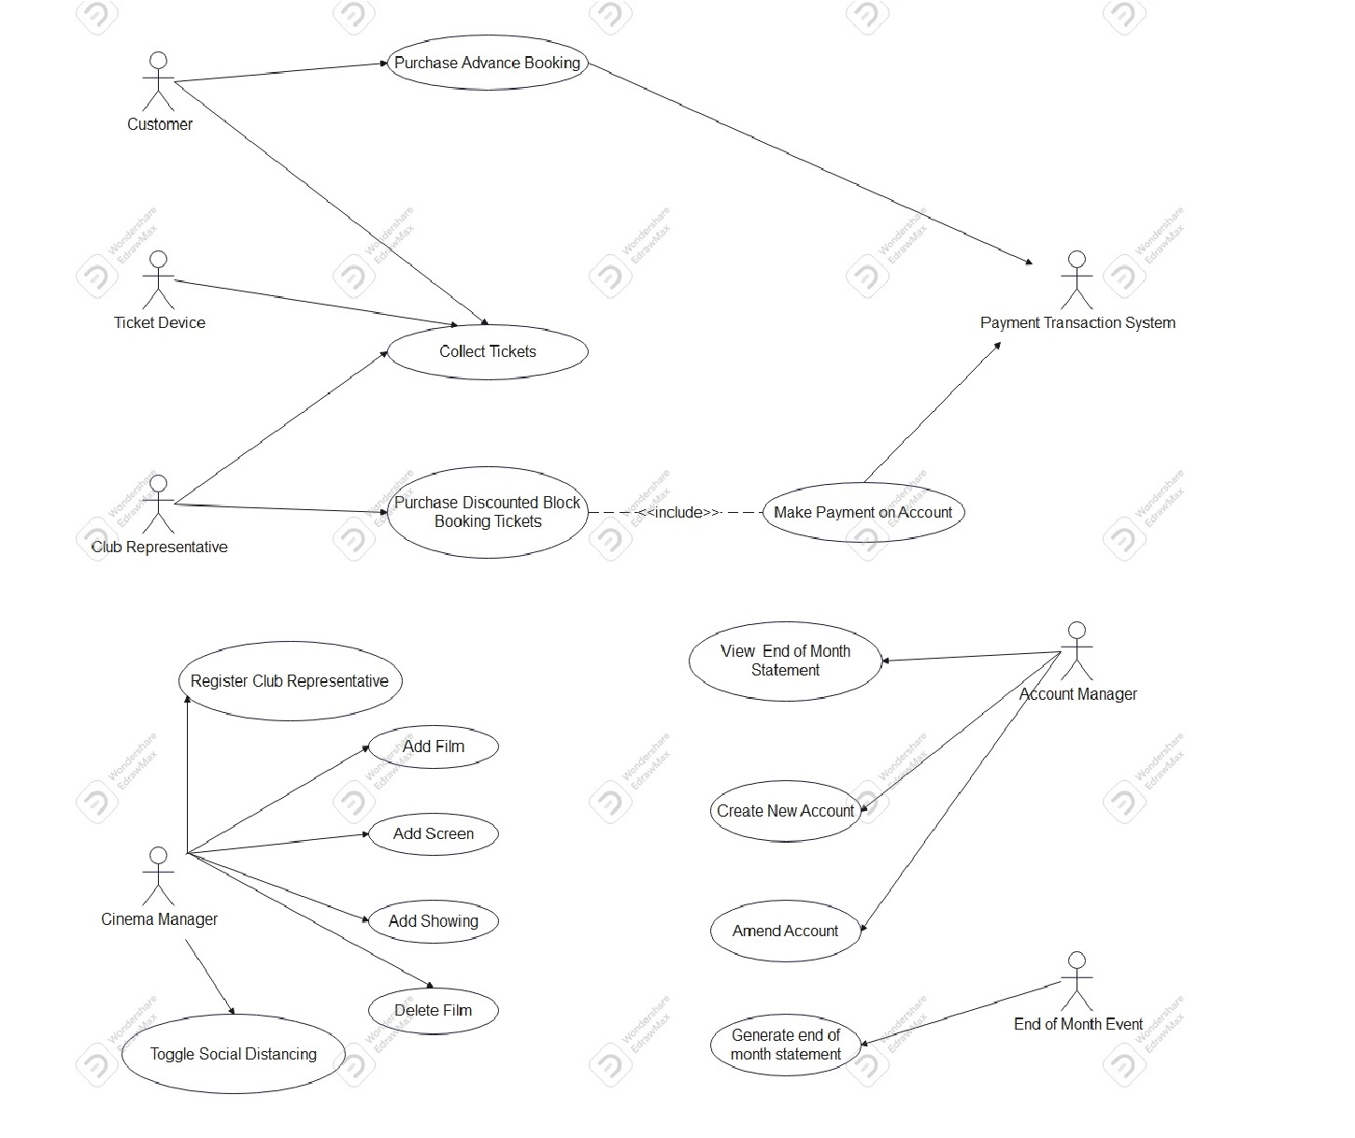

**Figure 6: Revision History Option in Lucidchart**

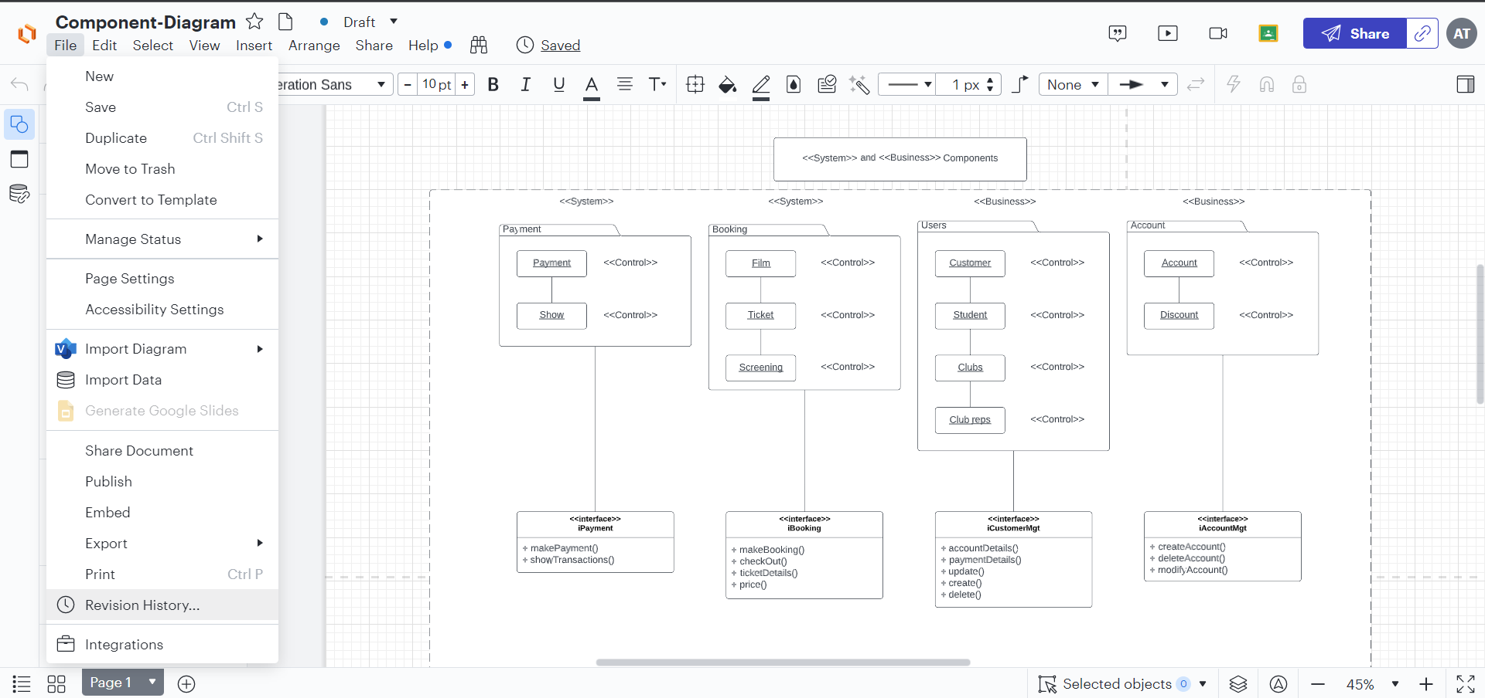

**Figure 7: Combined diagrams in one document in Lucidchart**

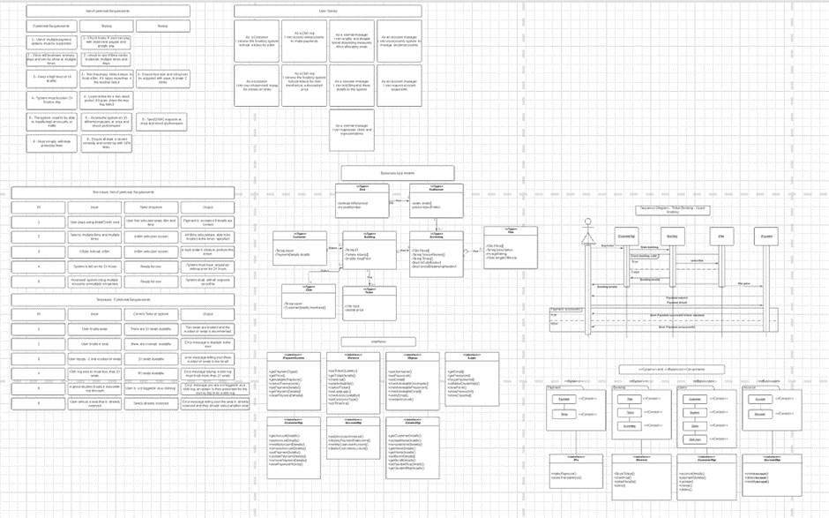

**Figure 8: Requirements models for UWEFlix Cinema System**

**Figure 9: Spell Check option within Lucidchart interface**

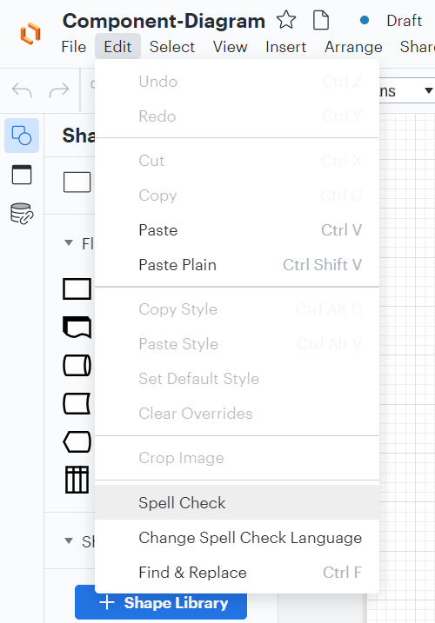

**Figure 10: Alignment example of diagram in Lucidchart**

**Figure 11: Add_film method**

**Figure 11: Film image after it was uploaded by the Cinema Manager**

